sai sukrutha@DESKTOP-V8UMPSS MINGW64 ~/Desktop/SEM 2/Machine Learning MLops/LAB (master)
$ git add .
warning: in the working copy of 'Desktop/SEM 2/Machine Learning MLops/LAB/preprocessed_churn.csv', LF will be replaced by CRLF the next time Git touches it

sai sukrutha@DESKTOP-V8UMPSS MINGW64 ~/Desktop/SEM 2/Machine Learning MLops/LAB (master)
$ git branch -M main

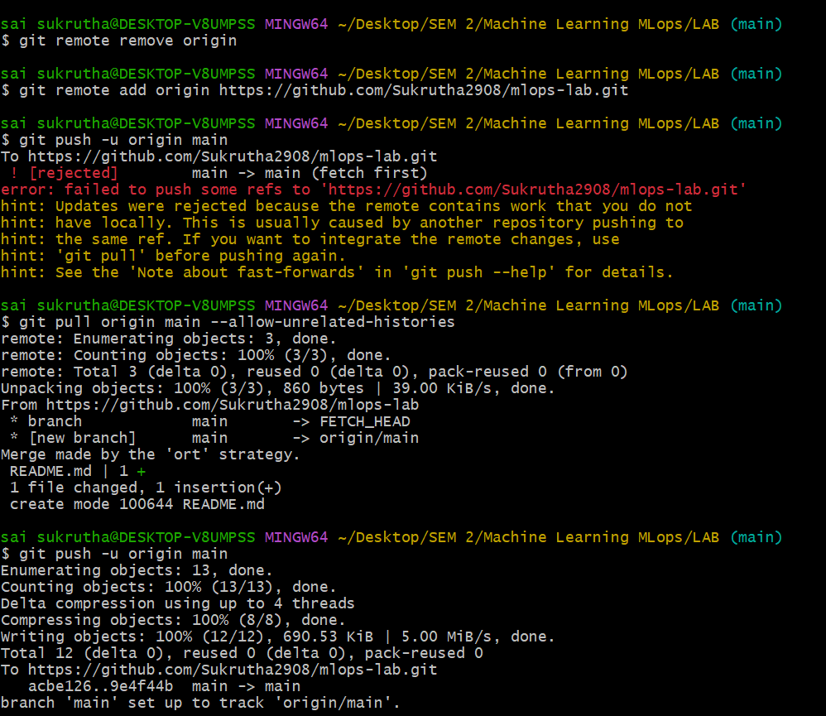

Experiment 5

